Assignment: Using Ansible to Install and Configure Nginx + Firewall

1. Introduction
Ansible is an open-source automation tool that simplifies IT operations such as configuration management, application
deployment, and orchestration. In this assignment, we will use Ansible to:
- Install Nginx web server on two Ubuntu servers.
- Configure and enable a firewall (UFW).
- Ensure Nginx is accessible on HTTP (port 80).
We will set up one server as the Ansiblehost (server1) and the other as ansibleuser (server2).

2. Environment Setup
- Server1: Ansiblehost ip: 172.31.33.14 (Ansible installed here).
- Server2: Ansibleuser ip: 172.31.35.14 (Nginx will run here).
- Operating System: Ubuntu Server (EC2 instances in AWS).
- Connection: SSH key-based authentication between servers.

3. Step 1: Install Ansible on Control Node
On server1:
sudo apt update
sudo apt install -y ansible
ansible –version - This installs Ansible and verifies the version.
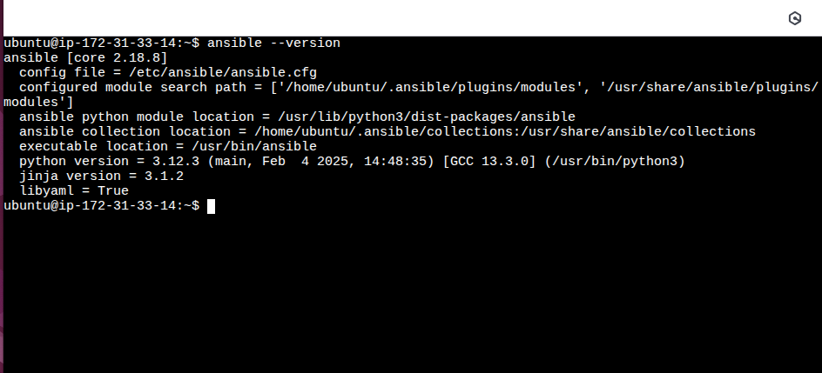

4. Step 2: Configure SSH Access
To manage server2 from server1, we need passwordless SSH login:
- Generate a key pair on server1(ansiblehost) (if not already present):ssh-keygen (Press Enter for defaults).
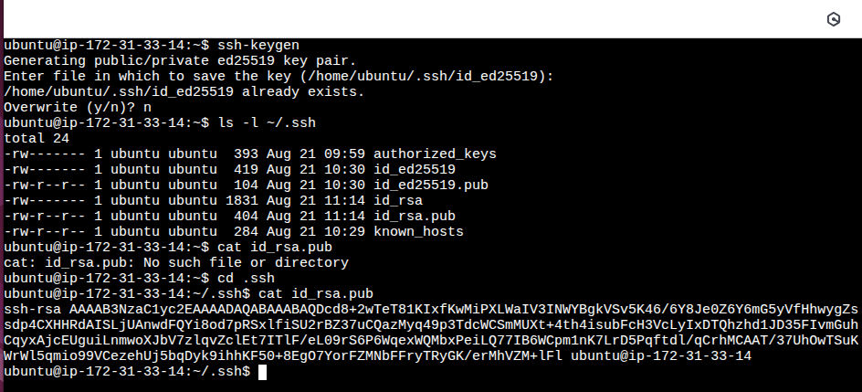
- Copythe public key to server2 in .ssh folder:
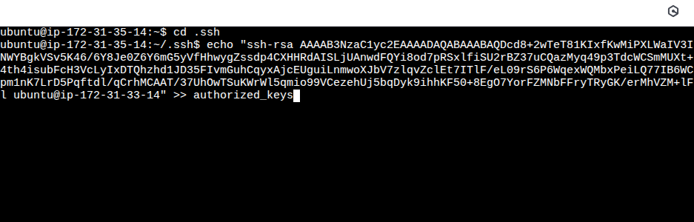
- Test SSH to check the connection establishment:
ssh ubuntu@ip-172-31-35-14
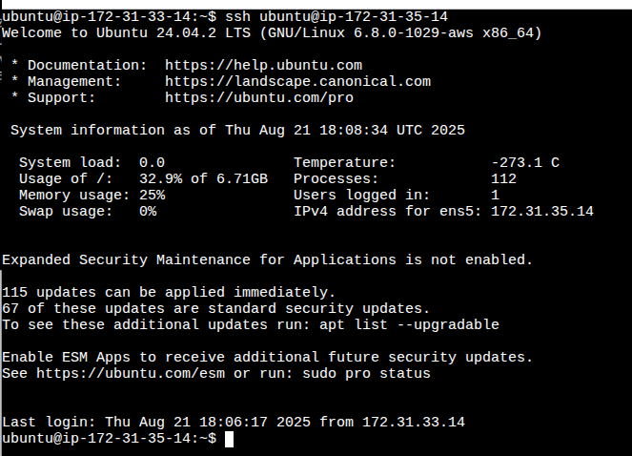

5. Step 3: Create Inventory File
Create a file inventory file on server1(Ansiblehost):
[webservers]
server1 ansible_host=172.31.33.14

- webservers: group of servers we want to configure.
- ansible_host: actual IP of the server.
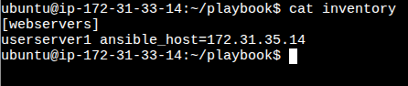

Test inventory with ping: ansible -i inventory.ini all -m ping
Expected output: SUCCESS for each server.
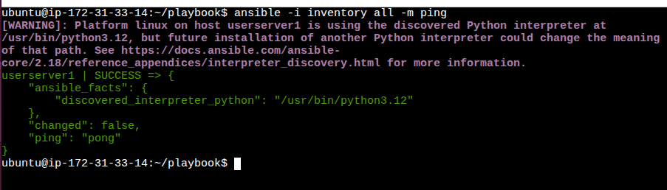

6. Step 4: Write Ansible Playbook
Create a file nginx_install.yml:
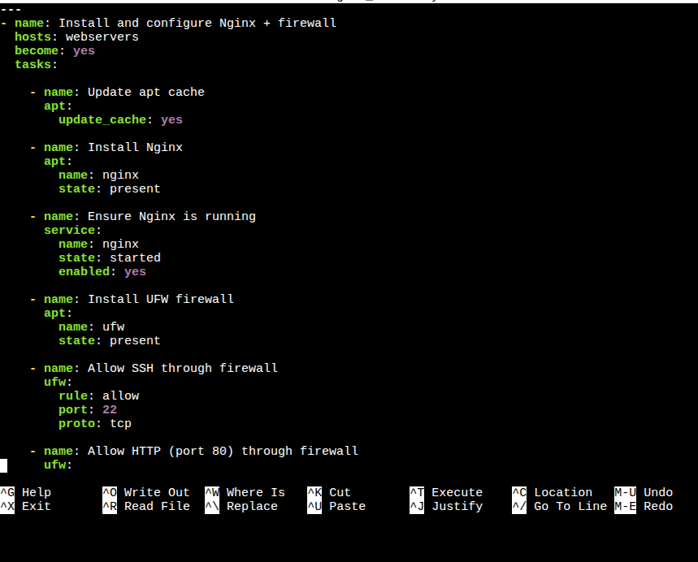

7. Step 5: Run the Playbook
Execute the playbook:
ansible-playbook -i inventory.ini nginx_install.yml
Ansible will:
- Update packages.
- Install and start Nginx.
- Install and enable firewall.
- Allow SSH and HTTP.
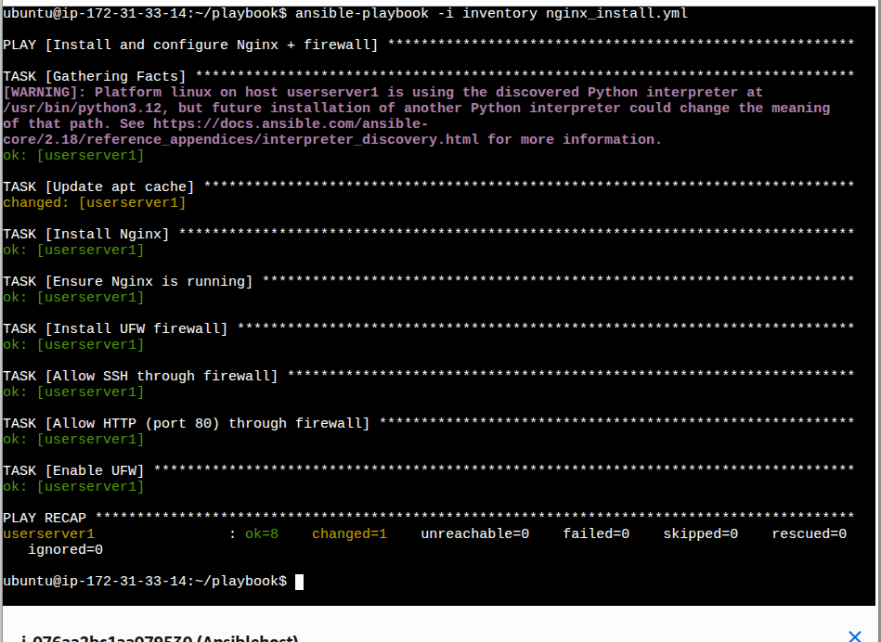

8. Step 6: Verify
On any webserver (server2): Ansibleuser
- Check Nginx service:
systemctl status nginx
- Check firewall rules:
sudo ufw status
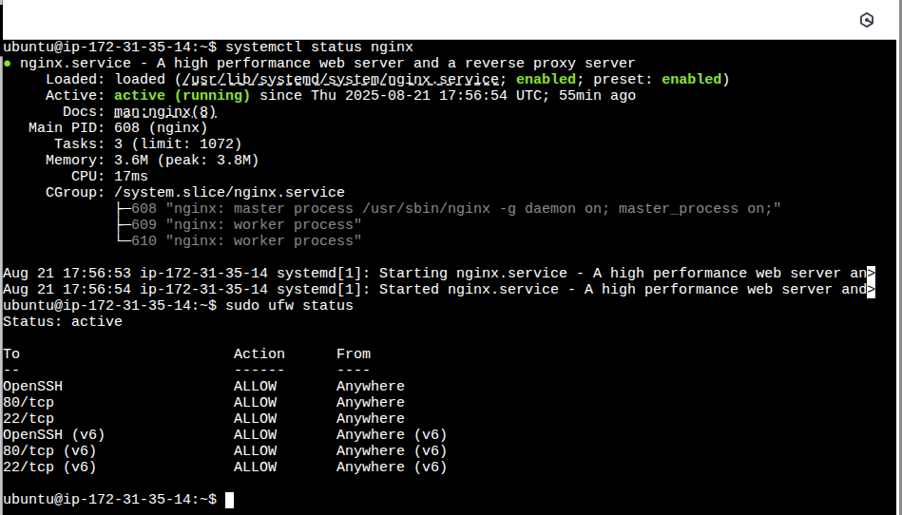
- Visit in browser: to see the Nginx default welcome page.
http://<server-public-ip> - http://13.60.74.145
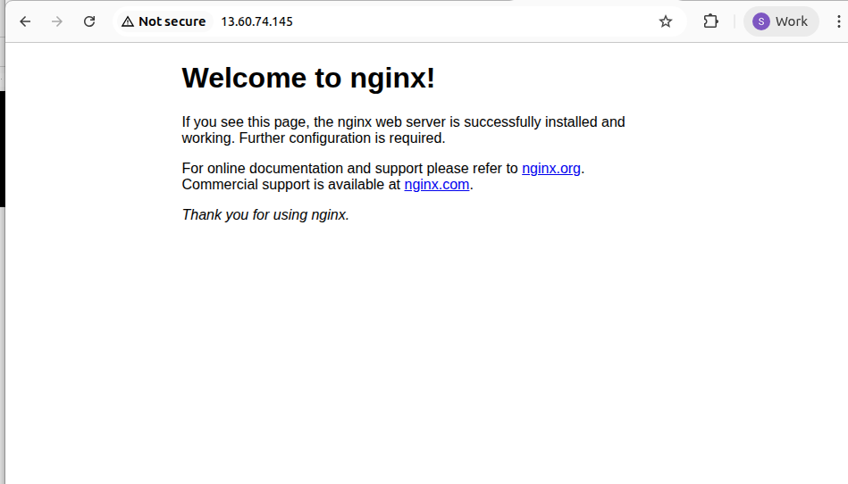

Assignment: Installing and Configuring Puppet with SSL + User Management

1. Introduction
Puppet is an open-source configuration management tool that automates system administration tasks such as installing software, enforcing configurations, and managing users.
In this assignment, we will use Puppet to:
- Install and configure Puppet Master (server) and Puppet Agent (client).
- Set up SSL certificates for secure communication.
- Use Puppet manifests to create and manage a Linux user.
We will configure one server as the Puppet Master and another as the Puppet Agent.
2. Environment Setup
- Server1 (Puppet Master)
Hostname: puppet
Private IP: 172.31.91.146
- Server2 (Puppet Agent)
Hostname: ip-172-31-86-36.ec2.internal
Private IP: 172.31.86.36
- Operating System: Ubuntu Server (EC2 instances on AWS)
- Connection: SSH key-based authentication between servers

3. Step 1: Install Puppet Server
On Server1 (Puppet Master):
sudo apt update
sudo apt install -y puppetserver
Enable and start the service:
sudo systemctl enable puppetserver
sudo systemctl start puppetserver
sudo systemctl status puppetserver
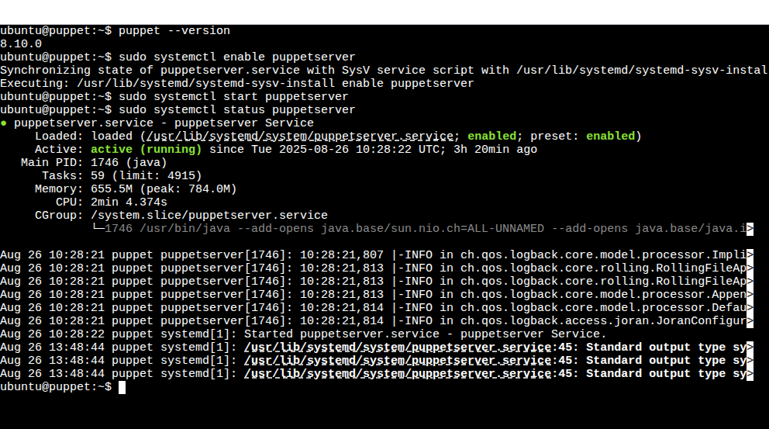

4. Step 2: Install Puppet Agent
On Server2 (Puppet Agent):
sudo apt update
sudo apt install -y puppet-agent
Verify:
/opt/puppetlabs/bin/puppet --version
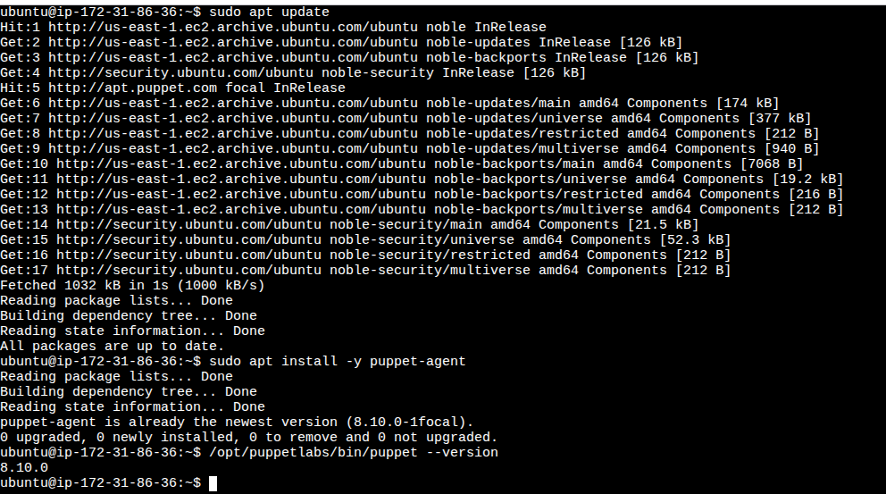
5. Step 3: Generate and Sign SSL Certificates
On Agent (Server2), run:
sudo /opt/puppetlabs/bin/puppet agent --test --server puppet
This generates a certificate signing request (CSR).
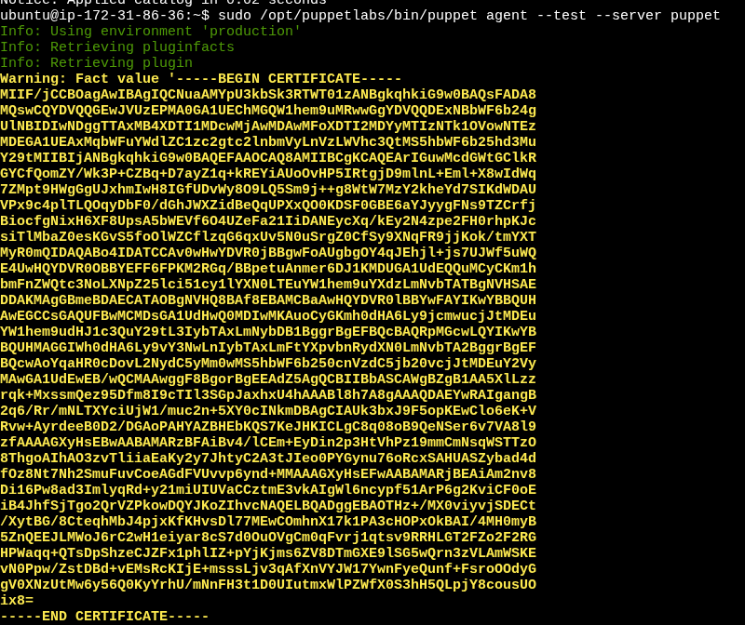
On Master (Server1), list pending CSRs:
sudo /opt/puppetlabs/bin/puppetserver ca list
Sign the CSR:
sudo /opt/puppetlabs/bin/puppetserver ca sign --certname ip-172-31-86-36.ec2.internal
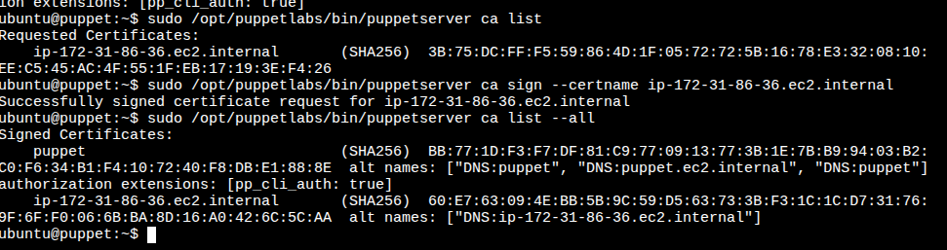

6. Step 4: Verify Agent-Master Communication
On the Agent (Server2):
sudo /opt/puppetlabs/bin/puppet agent --test --server puppet
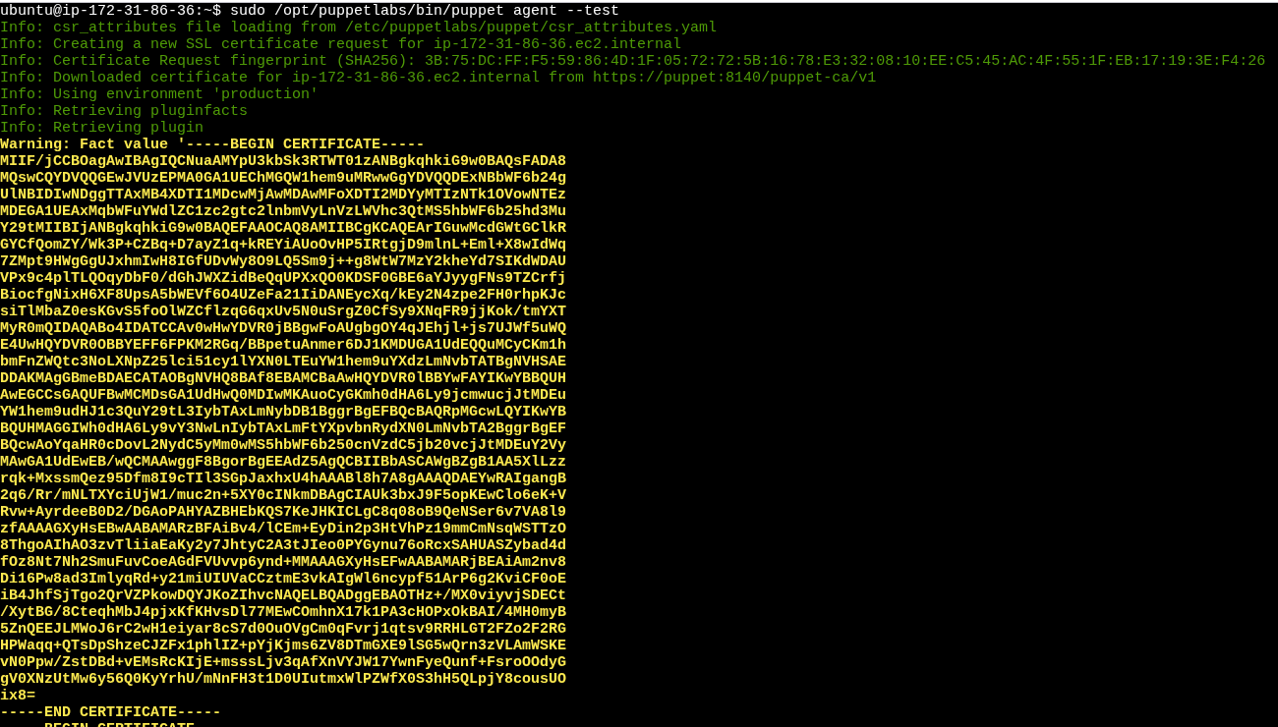

7. Step 5: Write Puppet Manifest for User Management
On Master (Server1), edit manifest:
sudo nano /etc/puppetlabs/code/environments/production/manifests/site.pp
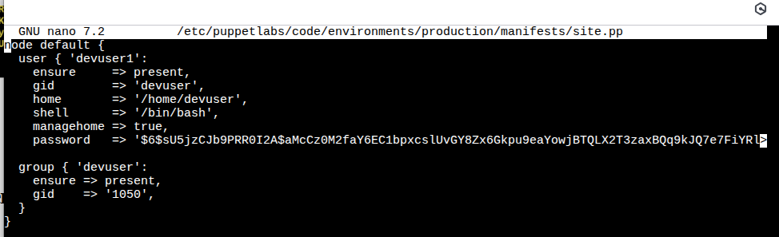

Step 6: Apply Manifest on Agent
On Server2 (Agent):
sudo /opt/puppetlabs/bin/puppet agent --test --server puppet
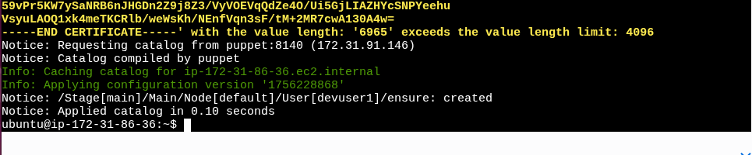

9. Step 7: Verify User Login
On Server2:
su devuser1
Password: DevPass123!
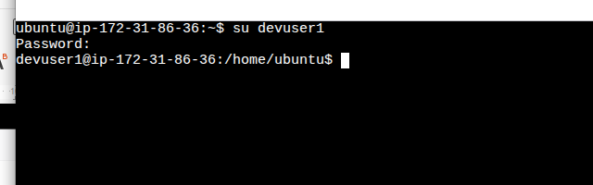

10. Conclusion
- Puppet Master and Agent were successfully installed and connected over SSL.
- Agent certificate was signed and trusted by the Master.
- Puppet manifest was applied to create and configure a new Linux user.
- This demonstrates how Puppet can be used for automated configuration management and user account provisioning.

